Webern Op. 18 mvt III
Music 222
Kate Paape
In the third movement of Anton Webern’s String quartet Op. 28, Webern uses a variety of techniques to expand the BACH motive, which is Bb-A-C-B. Despite the brevity of the motive repeated continuously, we never hear it with clarity, and he maintains variety and freshness by playing with register, rhythm, and altering time signatures and timbre. Webern constructs a 12x12 matrix that manipulates these four notes using inversion, retrograde, retrograde inversion and transposition. Interestingly, the original BACH motive is equivalent to its retrograde inversion, and the inversion is equivalent to the retrograde. This significantly restricts the Scope of Webern’s possibilities, leaving him with only 24 rows to work with.
Webern demonstrates the extensive musical material one can generate even under restrictive systems, and he proves how creativity can be freed when in the constrains of structure and formulaic techniques. Webern also limits his rhythmic figures, only introducing handful which are repeated canonically within the voices. While each row is constructed and played to its completion, Webern varies the way the each row is approached (sometimes forwards, sometimes backwards, sometimes in fragments) and the way the instruments trade off sounding the rows. Similarly, he is not at all shy with dynamics, and sharp contrasts and articulations. By incorporating these compositional techniques, the piece does not sound mechanical at all, but rather musical.
The piece appears to be constructed in five sections. The first section begins with each instrument playing two rows all the way through. The second section turns into a kind of fugue, where each instrument switches off tetrachords in the row, then each plays one full row through the end of the section. Section 3 is perhaps the most interesting, as it involves a series of trills that demonstrate the BACH motive in the most obvious way. Section four returns to the fugue between violin I and viola that cleverly completes violin II and the cello’s incomplete rows. Section five ends just like the beginning, each instrument plays two full rows to their completion without alteration.
Section 1
The first technique Webern uses is the convergence of rows between the instruments and their position of the row. Beginning with the A section (ms. 1-15) the piece is vibrant with action. The first violin begins on Db prime, moving across the row from left to right as the cello moves across the same row from right to left, beginning on Bb. Meanwhile, the second violin begins on the inversion of E and the viola begins on the prime of G. The viola and second violin and the outermost voices converge horizontally. The first four measures serve to grow the tension to the moment of convergence which occurs in ms. 5. In this measure, all the strings play arco and forte to emphasize the dissonant chromaticism and quick rhythms which are especially prevalent in this measure. The 4/8 time signature also contributes to the activity within this measure that abruptly stops when ms. 5 is cut in half with the 2/8 time signature. Webern uses ms. 6 as a relief from the tension of ms. 5, marking poco rit to slow down the time. Violin 1 echoes the fast motion of the previous measure, while the bottom strings play a single note, and violin 2 is silent. Violin 1 and the cello finish their rows at ms. 7, and the inner voices finally end at ms. 8.
Secondly, Webern uses canons to both build and disguise the Bach motive. As if in the honor of Bach, Webern constructs these rows like a fugue. The viola is a in canon with the first violin, transposed down a tritone for the majority of canon. Similarly, the cello and the second violin work together in a different canon, an inversion of the first canon. Thus, each instrument begins at a different time in two distinct canons that occur simultaneously. This complexity and rhythmic density add to the disguise of the Bach motive and add another dimension to the repetition of the rows throughout the piece. Beginning at ms. 8, the instruments start their second row, coming in one by one in the same order as the first row. This creates a perfect visual symmetry within the matrix, and a beautiful way to begin the movement.
Section 2
Section two is perhaps the most complex section of the third movement. This is the fugal section, with multiple strings of four notes overlapping and inverting in a variety of ways. The section begins with the Bach motive in F in the cello, then the second violin plays the inversion in Bb, altering the rhythm and articulation by doubling the first four notes in the row and adding staccato. There appears to be three rhythmic figures in this passage, that perhaps we might think of as three expositions. The expositions are: (1) the four 16th note figure, separated with a 16th note rest in the middle, (2) the eight 32nd note figure that doubles each note in the tetra chord, and (3) sweeping eight notes, whose longer duration appear to create some continuity within this section. The dynamics are also quite interesting in this passage as the extreme ranges and sudden silences are dramatic and startling. At the start, the cello plays the first rhythmic exposition pianissimo, as if barely alive. The second violin starts the second exposition at piano accenting the first note, decrescendos from the piano, melting into nothingness with the two measures of rests that follow. Finally, the viola begins the third rhythmic exposition, and this pushes us into the rhythmic fugue in which all three expositions overlap and canon with each other moving around the instruments.
At the start of section two, the cello begins on the prime of F, playing the first tetra chord before going silent. Violin II takes the second tetra chord in the row, continuing what the cello started. Finally, the viola finishes the row by playing the final four notes. Webern continues this kind of structure in the next row, which is the retrograde of F#.This time, the first violin, absent from the first row, starts the new row, F#-G-E-F. Meanwhile, Beginning in ms. 19, the cello is the only voice that plays through the whole row R(Bb). We see that the second violin is the next instrument to whom R(F#) row is handed off. However rather than the second violin simply playing the next set of four notes, which would be Dd-C-Eb-D, the second violin starts approaching from the other side of the row, playing the first four notes in the prime of A. Now we have the first violin coming from the right, and the second violin from the left on the same row. We see that the viola takes the second tetra chord in the middle and completes the row. Just as the violin finishes this row, the second violin begins a retrograde on D, in which the first tetra chord is the same as the second tetra chord of the retrograde in F#. Webern uses this overlapping brilliantly so the transition to the new row is seamless, and it makes it difficult for the listener to know where one row stops and the next begins. The R(D) row continues with violin I taking the second tetra chord, all while the cello underpins all of the trading that takes place in the upper voices. The last four notes in the cello’s row interestingly, are the last four notes in the row the violins began. The construction of this section is so elegantly crafted that we think the cello is acting independently of the top three voices, but it emerges as intertwined with the other voices the entire time. In this section, there is little stability of time, as Webern changes the time signature and writes in markings to speed up and slow down in almost every measure. In ms. 19-22, poco rit and tempo change twice per measure, further complicating the rhythmic and tonal density within this section.
In ms. 23, the first violin begins another row, A prime. In ms. 25 the cello takes the second tetra chord of this row, D-Eb-C-C#, and the viola finishes the row in ms. 25-26. Meanwhile, the viola begins a retrograde of Bb in ms. 24, and the second violin starts in on the prime of Db, so the two inner voices are working together from both sides again closing in on the bottom row. Ms. 26, though, is where all of the action happens. The viola simultaneously finishes the middle four notes of R(Bb), and the final four notes of P(A) which the outer voices had started in ms. 23. This measure is where the alternation and trading off of the rows finally ends, while a new canon begins to set off the final series of rows in section two. The four voices once again take hold of their own rows and play them to completion. In a canon beginning with the first violin playing P(F#), next the second violin on P(Bb), third the cello P(B), and finally after completing its previous row, the viola on P(Eb). These rows bring us to section 3. However, instead of keeping us in 2/8 or 3/8 time, as we had been altering between the two time signatures throughout all of section 2, but in ms. 28, the texture changes. there is a double barline and the time moves to 3/32. We no longer have our three rhythmic expositions introduced at the beginning of the section, now we have either one, two, or five 32nd note figures, and from ms. 28-37, the volume increases, never going below forte. It seems the change in time signature and volume creates the momentum we need to be propelled into the middle section where the most energy and tension resides.
Section 3
This section serves as a kind of gravitational pull in the middle of the movement, to which the other (outer) sections are drawn. Webern highlights the importance of these six measures not only with double barlines, but with fermatas over the double barlines. Webern certainly manipulates time in other areas of the movement, but the fermatas almost seem to suggest that within this center movement, time does not exist at all. Ms. 38 begins with a E-F then D-Eb trill in the second violin with viola pizzicato accompaniment the original BACH motive below. Without the wide leaps, this is perhaps the most audible variation of the BACH motive because of its narrow register. In ms. 40-41, the second violin grabs the viola’s eighth note accompaniment and raises it a half step, modifying the rhythms to fit the 3/16 time signature. The eighth notes become an 8th + a 16th, and the viola plays the prime of D. These measures anticipate the next two measures, likely the most memorable measures within the entire piece, indicated by the double barline that borders these two measures. Webern, perhaps, is again stressing their importance.
The time signature returns to 3/8 after its brief departure to 3/16. Then, for the first and only time in the entire piece, the violins play in unison. At the downbeat of ms. 42, the cello and the viola also play at the same time, although they depart from each other in the next measure. While short lived, the unison of these two measures almost serve to give coherence to the rest of the piece. In a sense, it is the code that cracks the puzzle of the rest of the movement. The code is, of course, the trills in the lower strings that sound the authentic BACH motive in the same register. While this section is the most obvious appearance, even here Webern hides it within the fast motion of the trills; only the most attentive listeners will be able to pick it out of the dense texture that he creates around this measure. The density is created by the violins playing arco with accents over the notes, and the trills marked sforzato with a crescendo that grows into section four.
Section 4
This section is similar to section two, fugue-like. After the dense texture and intensity of section three, it seems that section four must drop in volume, and the whole section is quiet. The voices once again begin in canon, each starting their own new row. Just when you begin to think you have understood the construction of Webern’s symmetries, he surprises you yet again, as these rows are perhaps the most perplexing of the entire piece. Violin II and the cello play the first eight notes of their rows, seemingly incomplete, while violin I and the viola work the rows more subtly. The second violin starts on prime of B in ms. 46, the cello starts in ms. 47 on prime of D. Webern again connects the rows seamlessly as the second set of four notes in P(B) are D#-#-C#-D, which is the retrograde of beginning of P(D) which appears in the same measure as D-C#-E-Eb. Since the second violin stops abruptly at ms. 50 ending on Eb rather than playing the whole row from beginning to end, the cello completes the second violin’s row with its second set of four notes G-Ab-F-F# being the retrograde of Violin II’s final four notes. Webern is demonstrating the circularity of his matrix, showing how each row loops back around into the next set of rows.
At first glance, it may be intuitive to see violin I and the viola working independently of of violin II and the cello, as both voices begin their first four notes on the prime and sound the second four notes on the retrograde of the last four notes in the row. For instance, violin I starts on P(Eb) and plays the first four notes in the row, Eb-D-F-E. Rather than moving consecutively through the row though, violin I approaches from the other side of the same row playing C-Db-Bb-B, collapsing in on itself just as we saw in section two. The viola follows this same pattern beginning on F# prime, first playing the first four notes, then starting the last four notes of the row in retrograde fashion. Thus, it would seem that the first violin and viola work together while the second violin and cello work together. What we find though, is that P(Eb) and and P(F#) are directly above and below P(D). Additionally, the last four notes of P(F#) are indeed the first four notes of P(D), and the last four notes of P(Eb) are the first four notes of P(B). Thus, P(Eb) played by violin I is directly related to P(B) in violin II, and P(F#) is directly related to P(D) played by the cello.
Just as with section two, Webern plays with time and alters between poco rit and tempo almost twice per measure. At ms. 51, the top voices are silent, and there is a poco rit as the cello plays the seventh and eighth notes in the row, and there’s another fermata at the bar line. At this point in the piece, we begin to wonder if Webern really did fail us and leave three incomplete rows. For a moment there is silence, a 16th note rest where we doubt him, but despite the slowing down, we know that Webern, of course, would never fail us. One more mini canon emerges in ms. 52-53 between the viola and violin I. The viola picks up again in ms. 52 playing G-F#-A-G#, which simultaneously completes the last four notes of P(B) and the middle four notes of P(Eb) in retrograde form. The first violin starts at the last 16th note in ms. 52 and plays the Bach motive Bb-A-C-B in its pure form which completes the last four notes in P(D) and the middle four notes of P(F#) in retrograde form. All of the rows are satisfactorily completed as expected, and we are pushed into the final section.
Section 5
This section ends with the same four rows the beginning started with, the prime and retrogrades of Bb, E, Db, and G. it is in the same symmetrical structure described in section one. The final section begins in forte, and with exception to ms. 56-57 in violin I and cello, ms. 54-60 remain loud and determined to end the movement with power. When we get to the last iteration of the rows at ms. 61, the volume only intensifies to fortissimo, creating upmost tension until the mood changes suddenly at the end of ms. 66 when there is a sudden decrescendo to piano in all four voices, moving into pianissimo as if the music is fading away.
Taking a step back and looking at the broad construction of the piece as an entire moment, the movement is put together just like the symmetrical row. The first and last sections begin in symmetry, ending on the same rows as it began. The second and fourth sections are much more complex with intertwining rows in a canon; rows that start and end in different instruments, time is sped up and slowed down, and there is a thick dynamic contrast, all the while creating a symmetry between these two mid-sections, so every row is played to its completion. Section three is the heart of the movement, and the densest section in which the outer sections are pulled inward like gravity and outward again to create what could be imagined as a visual symmetrical shape. Webern’s overlapping of rows creates ambiguity in the sense that each row melts into the next which further perpetuates the attraction and repulsion of the rows both within the piece and through the symmetry of the movement as a single unit.
The Rows
Section 1
VI P(Db) ms. 1-7, R(Db) ms. 8-13
VII R(E)) ms. 3-8, P(E) ms.9-15
VA P(G) ms. 2-8, R(G) ms. 9-14
C R(Bb) ms. 2-7, P(Bb) ms. 8-14
Section II
VI R(Gb) ms. 19-20, P(F) ms. 21-22, P(A) ms. 2-24, P(F#) ms. 26-33
VII R(Bb) ms. 17, P(A) ms. 20-21, R(D) ms. 22-23, P(Db) ms. 24-25, P(Bb) ms. 26-35
VA P(Db) ms. 18-19, R(D) ms. 21-22, R(Bb) ms. 24-26 (goes to F#) R(Eb) ms. 27-37
C P(F) ms. 16, R(Bb) ms. 19-25, R(D) ms. 25, P(B) ms. 27-36

Section 3
VI R(F#) ms. 42-43
VII (E)) ms. 38-39, P(B) ms. 40-41, R(Ab) ms. 42-43
VA P(B) ms. 38-39, (D) ms. 40-41 R(B) ms. 42-43,
C R(B) ms. 42-43
Section 4

VI P(eb) ms. 44-45 R((c) 46-48, P(Bb) ms. 52-53
VII P(B) ms 46-50 (to Eb)
VA P(F#) ms. 45-46, R(Eb) ms. 48-49, P(G) ms. 52-53
C P(D) ms. 47-51 (until F#)
Section 5

VI R(Bb) ms. 54-60, P(Bb) ms. 61-67
VII R((E) ms. 55-61, P((E) ms. 62-68
VA P(Db) ms. 54-60, R(Dd) ms. 62-67
C P(G) ms. 55-61, R(G) ms. 62-68
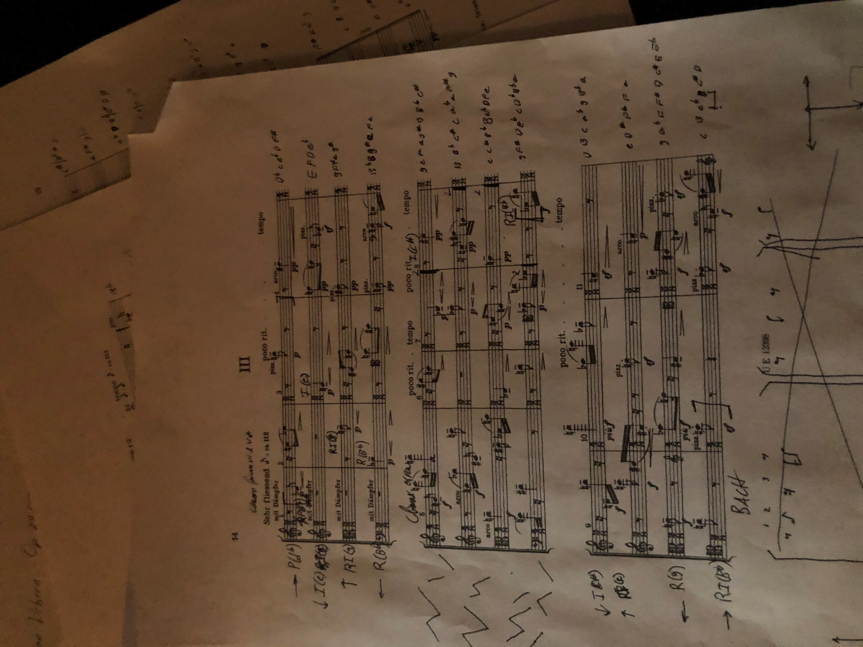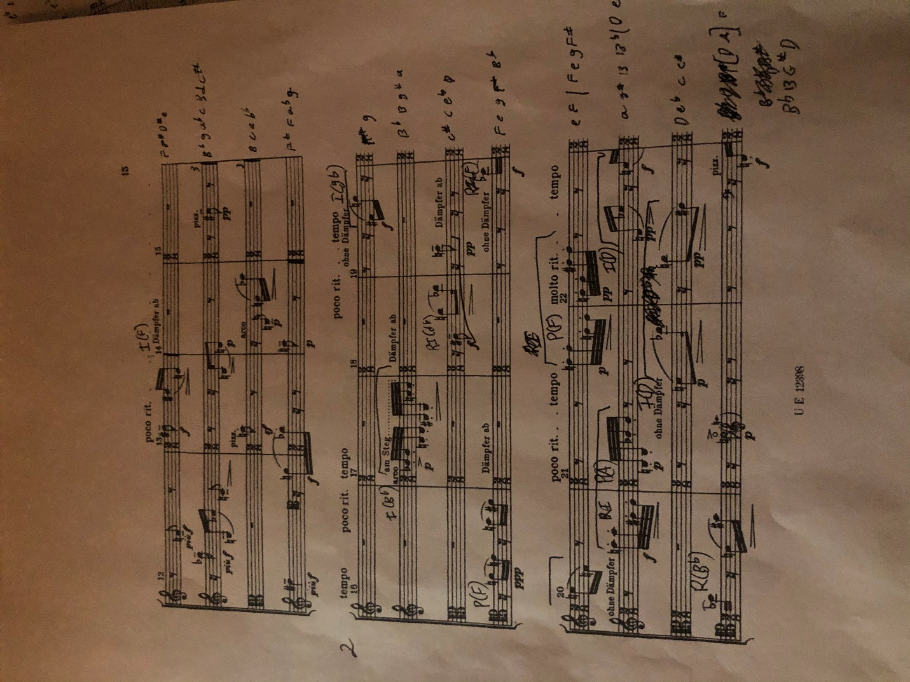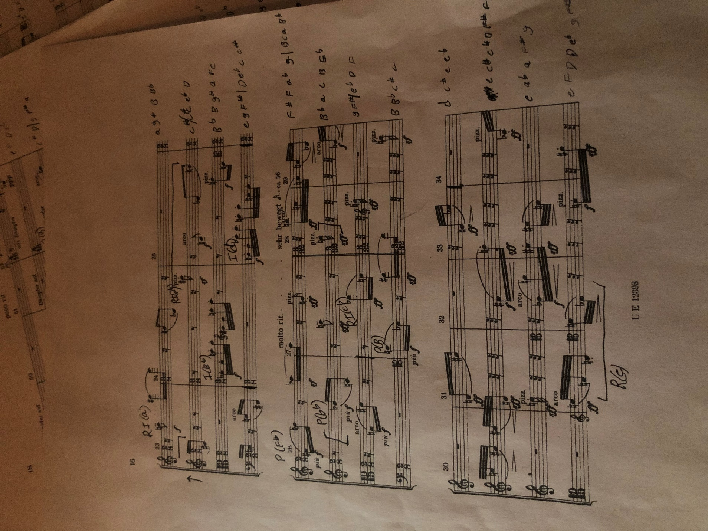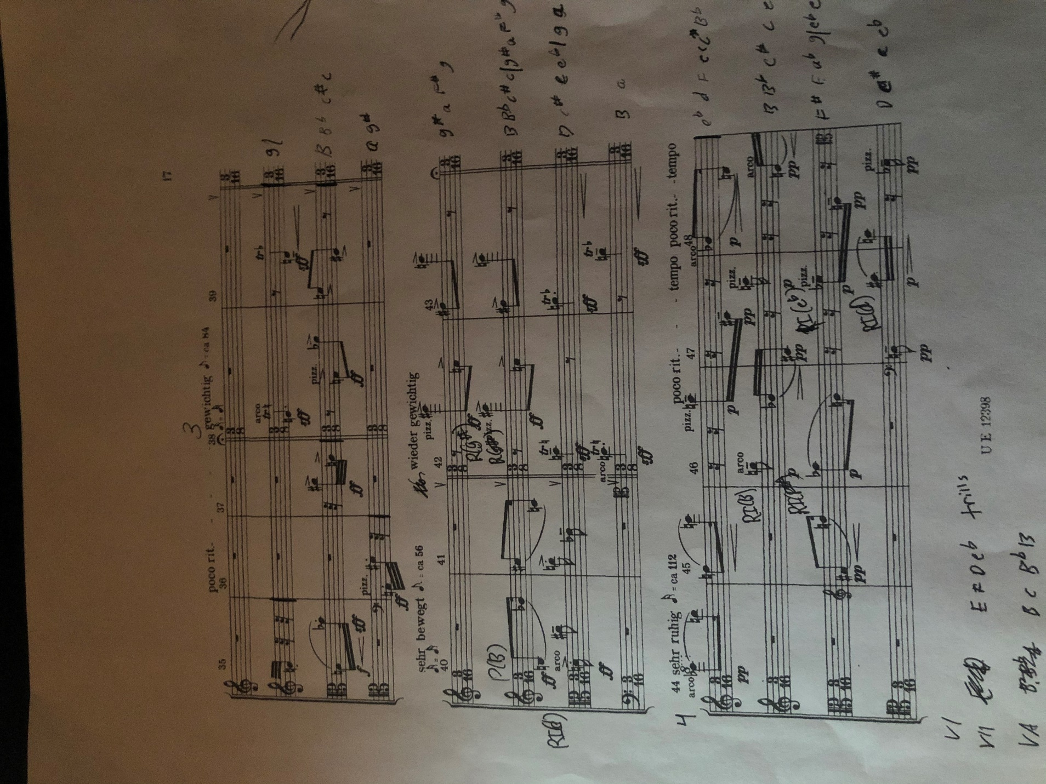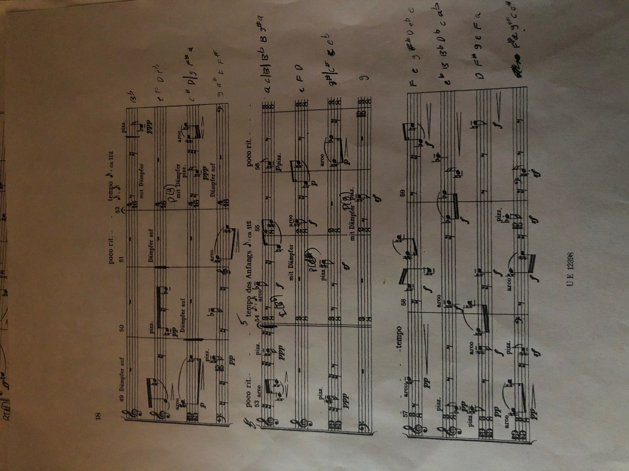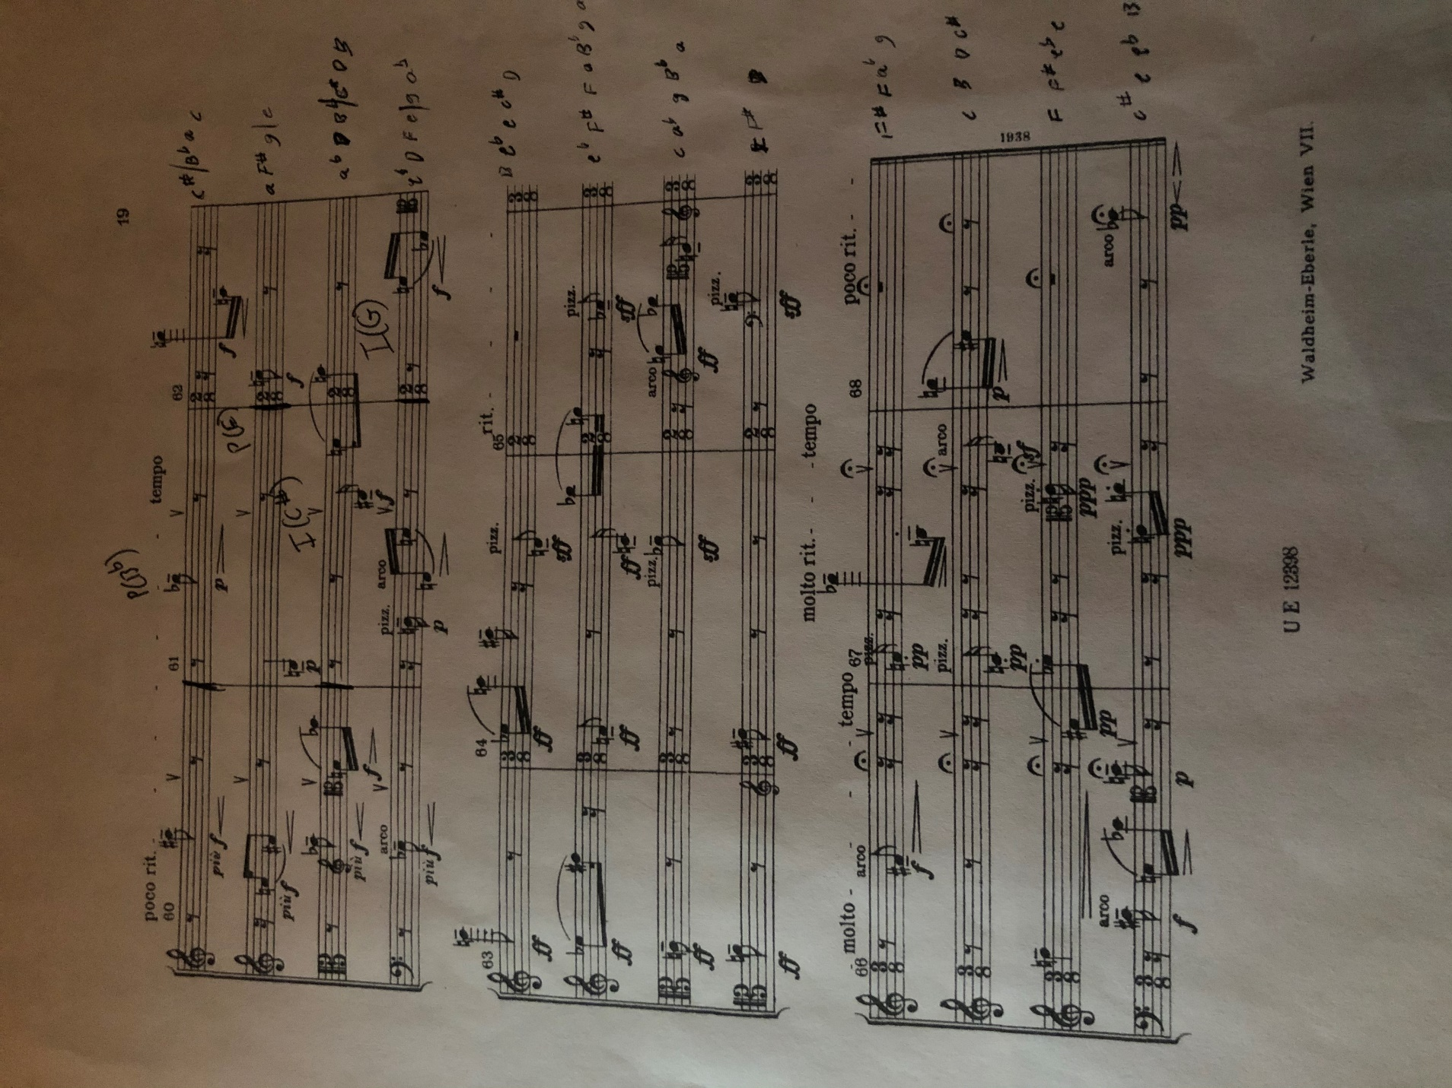

Rhythm Analysis of Sections 1 and 2

